**max-temp.txt in local FS**

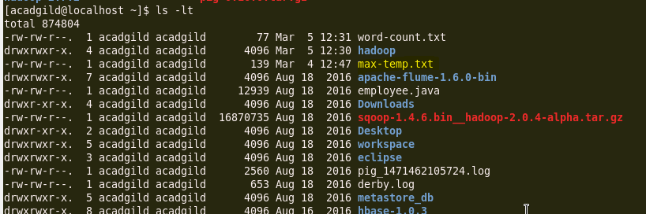

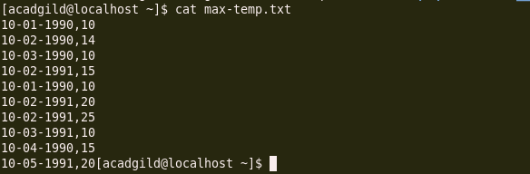

**Move this file to HDFS at /user/acadgild/Hadoop**

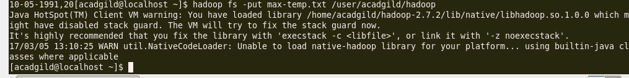

**File moved to HDFS in the path mentioned as /user/acadgild/Hadoop**

